PRESS RELEASE

No.48/SP/TKP-ASEAN2023/04/2023

PUBLIC COMMUNICATION TEAM

Foreign Minister Retno: Indonesia Wants ASEAN to Remain Distinguished and Relevant

Labuan Bajo, Kominfo Newsroom – Minister of Foreign Affairs Retno Marsudi said that Indonesia wants ASEAN to remain distinguished and relevant as the theme carried by the Chair of ASEAN 2023 ASEAN Matters: Epicentrum of Growth at the 42nd ASEAN Summit in Labuan Bajo, West Manggarai, East Nusa Tenggara, 9-11 May 2023.

"So, we want ASEAN to remain distinguished, relevant, able to hold its unity to hold its centrality in maintaining regional peace and stability. So that Southeast Asia can still become the center of world economic growth," said Retno Marsudi at Puncak Waringin Labuan Bajo, West Manggarai, Tuesday, 25 April 2023.

Retno Marsudi explained that all meeting documents were being negotiated, even before the 42nd ASEAN Summit.

Negotiations have been carried out at the Senior Official Meeting (SOM) to the level of the foreign minister.

"Let's see if the negotiation finished in SOM or not. If not, we'll continue the negotiations at the foreign minister level, then submit it to ASEAN leaders for adoption," she said.

Retno explained that several main meetings are between ASEAN leaders and parliament, youth, business, and high-level task forces.

Then, the Indonesia-Malaysia-Thailand Growth Triangle Sub-Regional Economic Cooperation (IMT-GT) and the Brunei Darussalam-Indonesia-Malaysia-Philippines East ASEAN Growth Area (BIMP-EAGA) Cooperation.

Foreign Minister Retno stated that President Joko Widodo will chair seven meetings out of the eight meetings, while the Prime Minister of Malaysia will chair BIMP-EAGA.

The series of the 42nd ASEAN Summit in Labuan Bajo will begin on May 8, 2023, with the Senior Official Meeting agenda.

The next meeting will be held at the Minister of Foreign Affairs level on May 9, 2023. "The peak of the summit will be May 10 and 11," said Retno.

Archipelago tourism promotion event

The 42nd Association of Southeast Asian Nations (ASEAN) Summit in Labuan Bajo, East Nusa Tenggara, can be a venue for promoting Indonesian tourist destinations.

"Of course, this is a great opportunity to promote Labuan Bajo to ASEAN and the world," said Retno.

Minister of Foreign Affairs Retno, who accompanied President Joko Widodo while reviewing several locations for the Summit in Labuan Bajo, explained the importance of the region's infrastructure readiness to host the ASEAN Summit.

Regarding airports, the government has prepared international and domestic routes at Komodo Airport, Labuan Bajo.

"So there will be immigration and conveyor belt facilities that will specifically receive goods from arriving abroad," said Retno.

Retno further said that President Joko Widodo also advised ensuring the readiness of the hotels for the leaders of ASEAN member countries during the Summit taking place on 10-11 May 2023.

"The President gave clear instructions to prioritize hospitality and comfort of our guests who will attend the 42nd ASEAN Summit in Labuan Bajo is maintained," she said.

The government has also prepared various preparations, including the substance of the summit discussion, which according to Foreign Minister Retno, are on the right track.

"The readiness checking is carried out in detail. So hopefully, our big duty as chair of ASEAN through the holding of the 42nd ASEAN Summit can run smoothly," said Retno. (Francisca/Elvira/TR)

***

Director General of Public Information and Communications of the Ministry of Communication and Informatics – Usman Kansong (0816785320).

Get more information at https://infopublik.id.

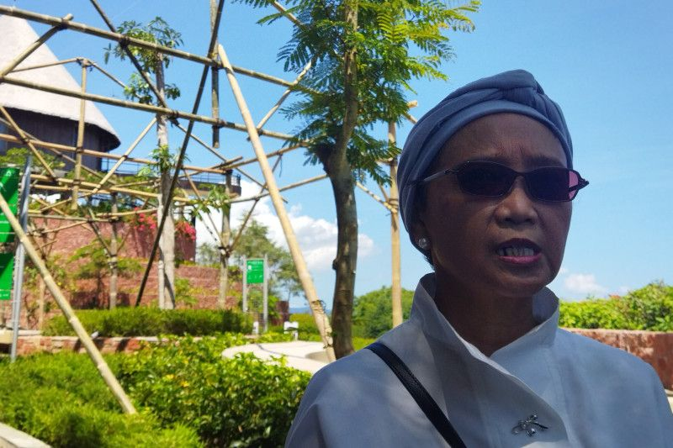

Minister of Foreign Affairs Retno Marsudi met by journalists after the Waringin Peak inspection in Labuan Bajo, West Manggarai, NTT, Tuesday, 25 April 2023. ANTARA/Franciska Mariana Nuka

